**Research**

<https://stackoverflow.com/questions/12521849/how-to-embed-a-mov-file-in-html>

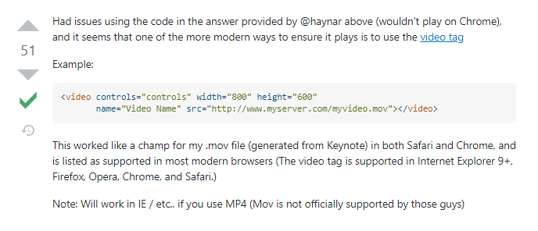

<https://www.freecodecamp.org/news/css-media-queries-breakpoints-media-types-standard-resolutions-and-more/>

<https://www.w3schools.com/css/css_rwd_mediaqueries.asp>

<https://www.fixrunner.com/how-to-fix-media-query-not-working-in-wordpress/>

<https://www.diffchecker.com/diff>

<https://www.w3schools.com/howto/howto_js_slideshow.asp>

<https://www.w3schools.com/howto/howto_js_hover_tabs.asp>

<https://www.w3schools.com/howto/tryit.asp?filename=tryhow_css_shapes_oval>

<https://threejs.org/docs/index.html#manual/en/introduction/Creating-a-scene>

<https://stackoverflow.com/questions/2117046/how-to-show-live-preview-in-a-small-popup-of-linked-page-on-mouse-over-on-link/16625709>

<https://www.w3schools.com/howto/tryit.asp?filename=tryhow_css_menu_icon_js>